Creating new Dynamic Web project:

Go TO the New->Dynamic web project->

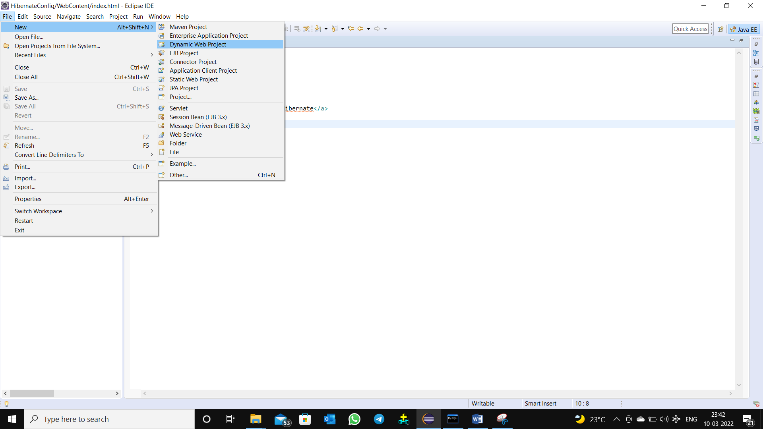

Here u create your project name and set apache and set dynamic web version it using below 3 is best to performing press Next->

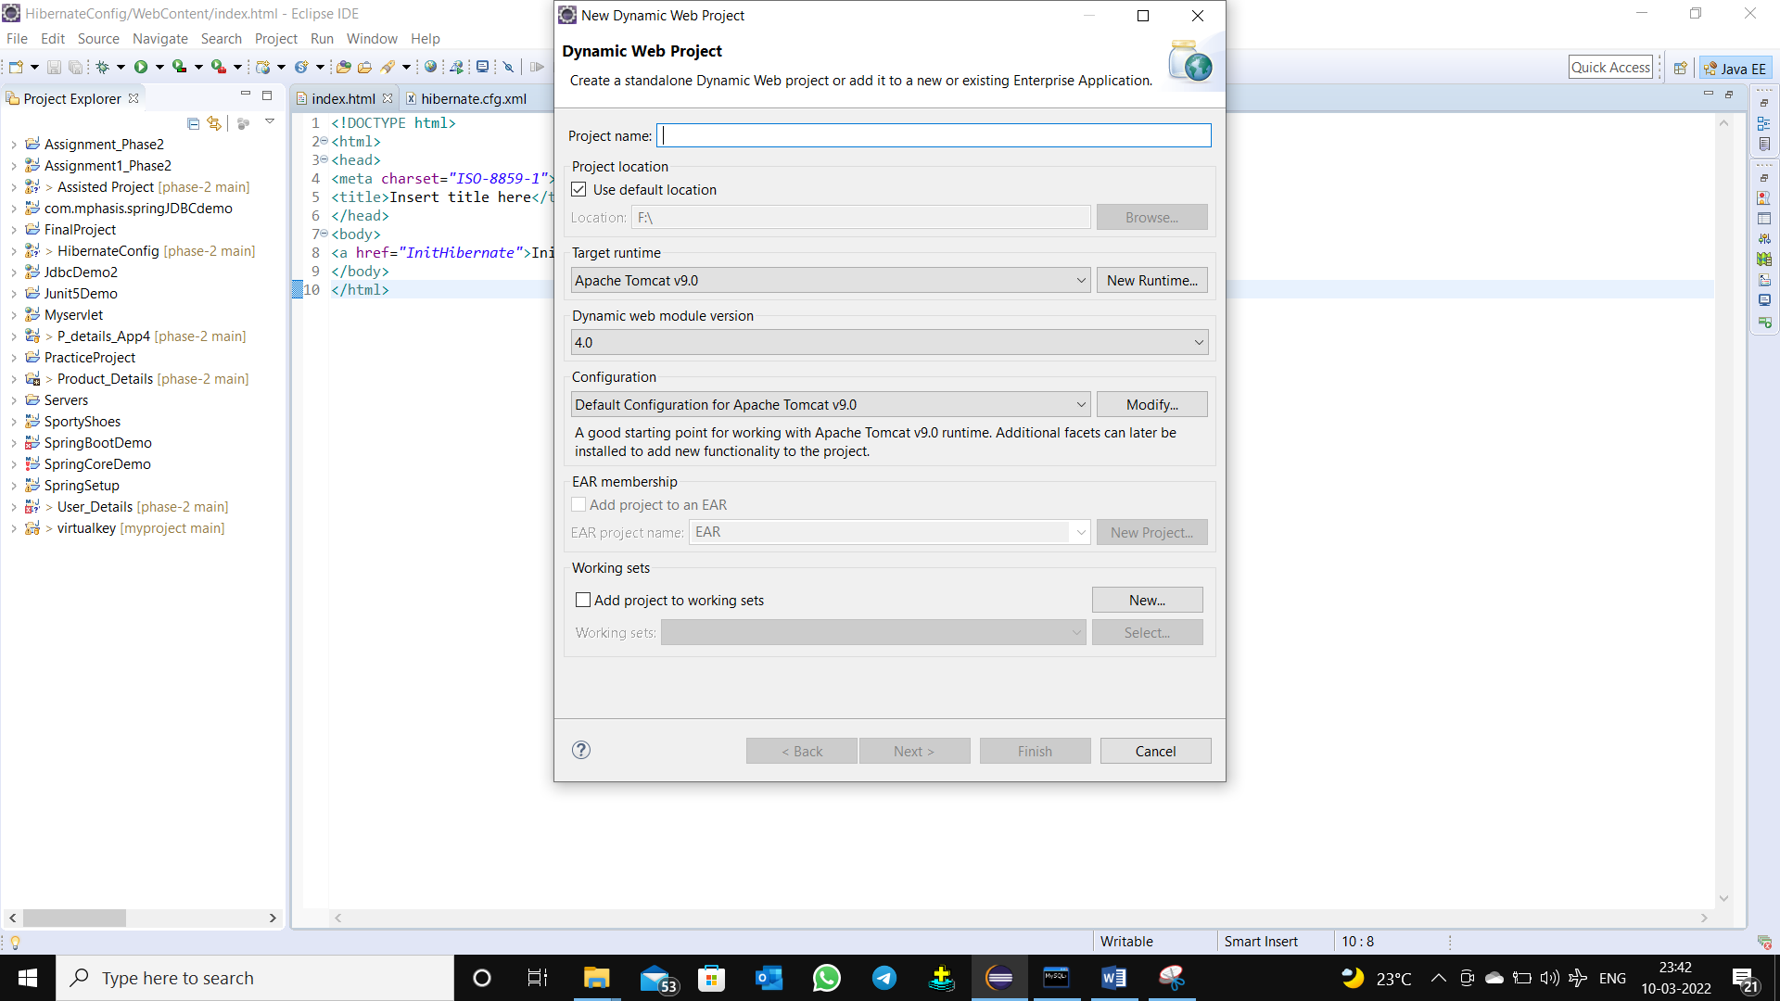

Here it creates java configurations project for building a java application src->Next->

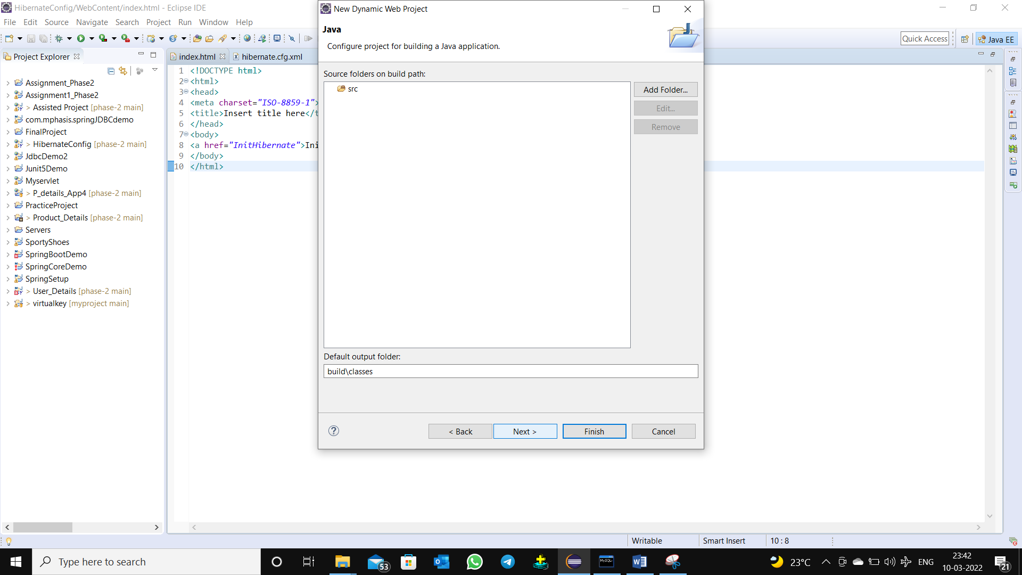

Here it configures the Web module click the Box where it showing Generate web.xml deployment descriptor clicks Finish.

It generates the web project

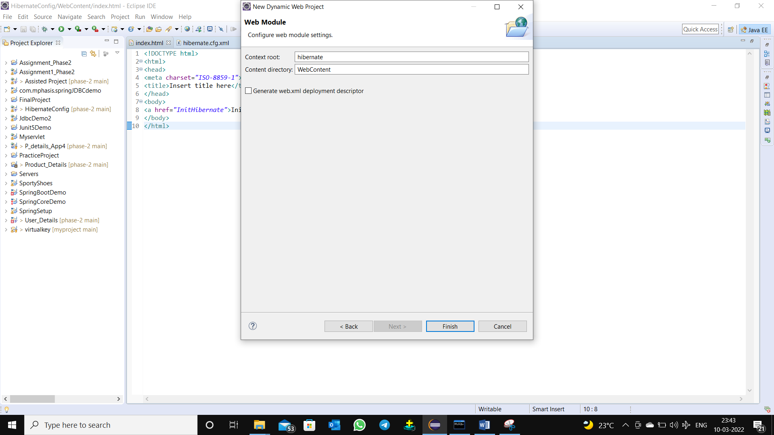

Here We creating New-> java class

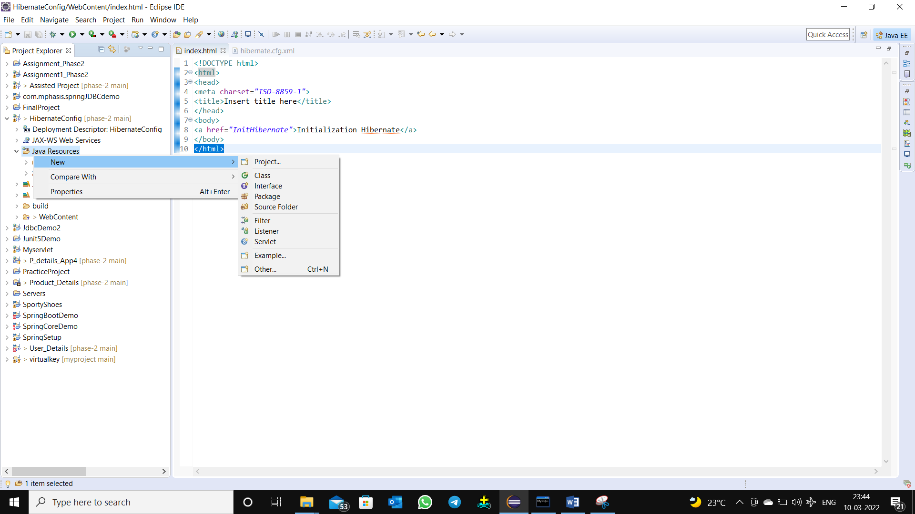

Here we creating servlet New-> Servlet

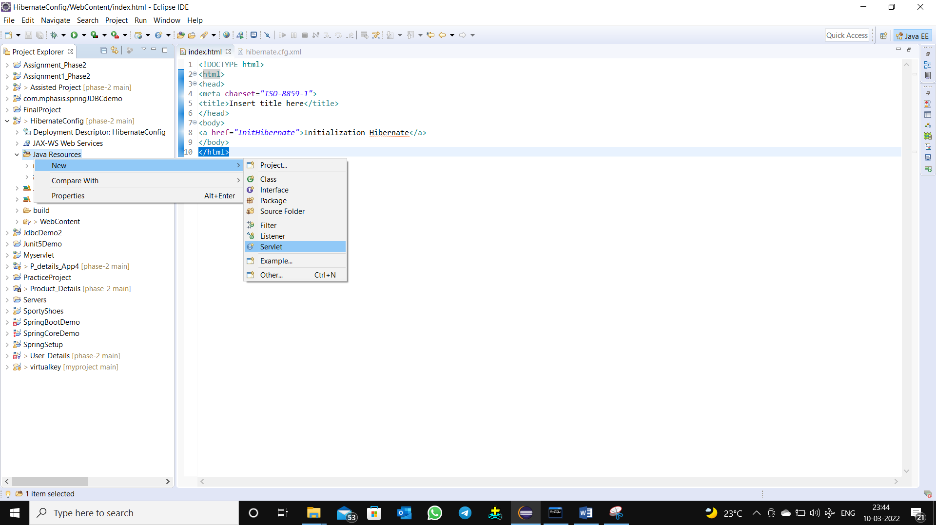

Here we Creating HTML New->HTML File

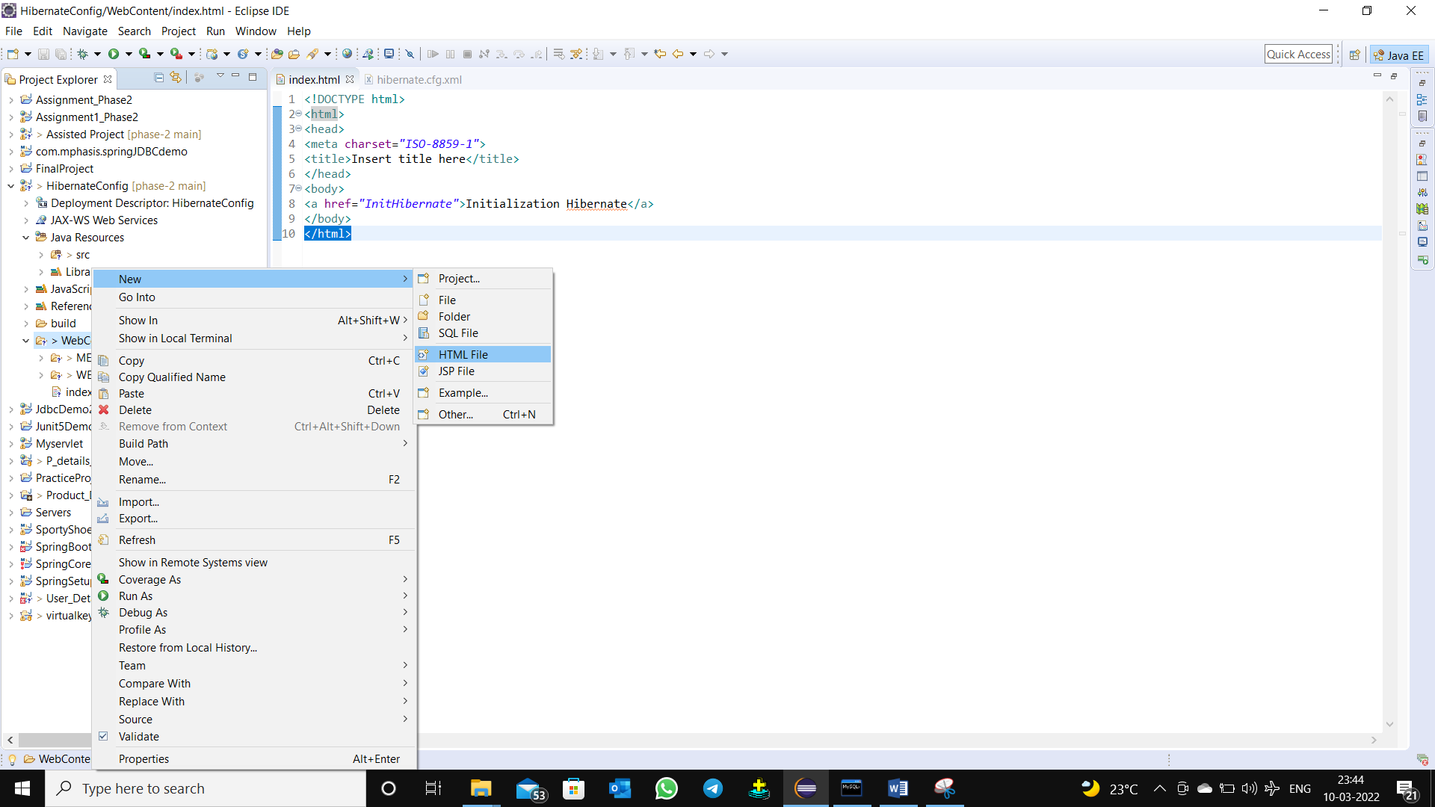

Go to the project click on the properties

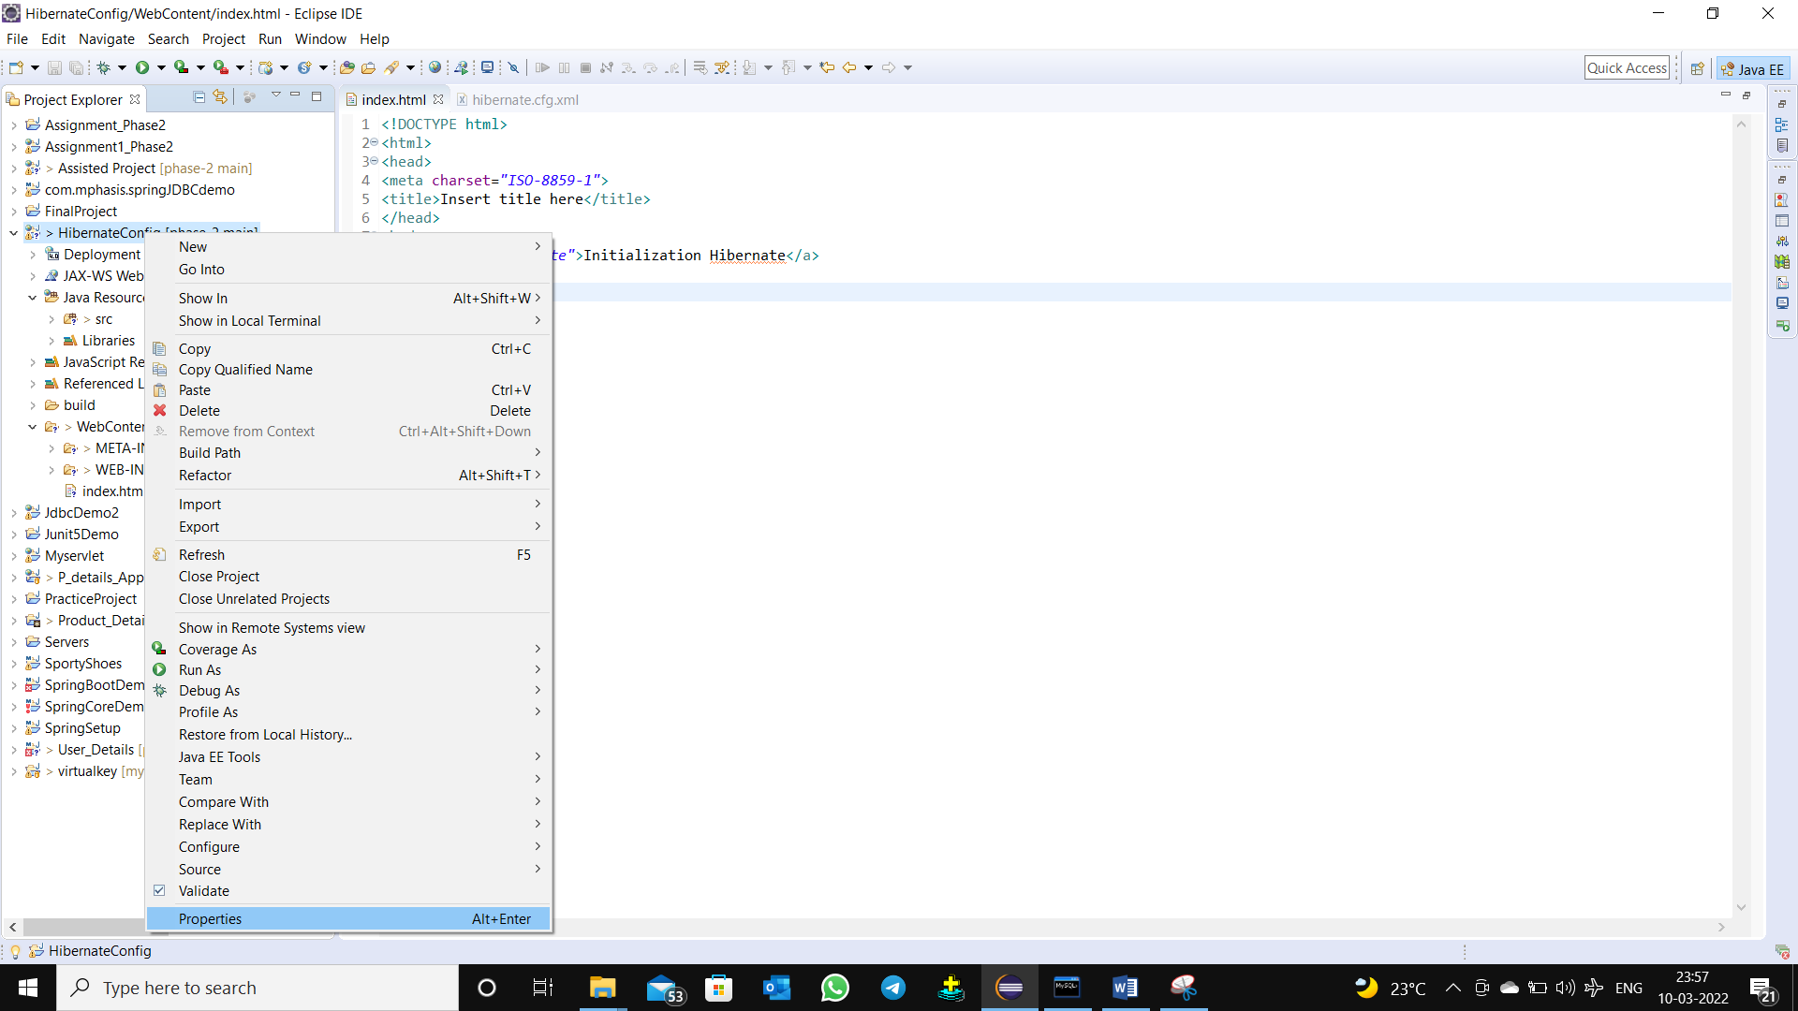

Set Required jar file in the java build path next click the apply and close .

